1. We needed to normalize the data to have better processing by subtracting the average of the dataset and dividing by the standard deviation of the dataset.
2. I chose by network by trying several layered networks by running two concurrent computers with the same reg and epochs and learning rate but one with 3 layers and another with 4 layers. The one with three layers came up with the better ACCR, so I started changing the lr and reg to find the best architecture and stopped when I reached a sufficient percentage.
3. 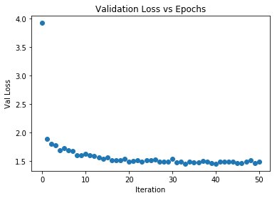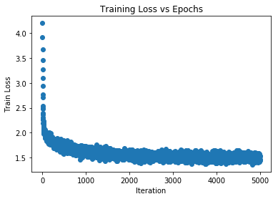
4. The average accuracy (ACCR) of the NN of my own implementation was 59.7%. My Keras implementation got me an 68.7% accuracy. Thus, the average ACCR is 64.2%.

Data Own Implementation NN:

ACCR: 0.597

0 0.5882352941176471

1 0.8035714285714286

2 0.5454545454545454

3 0.42391304347826086

4 0.5454545454545454

5 0.35294117647058826

6 0.6728971962616822

7 0.6078431372549019

8 0.7474747474747475

9 0.6019417475728155

Epoch 0 / 50 train acc 0.168 val acc 0.17

Epoch 1 / 50 train acc 0.363 val acc 0.367

Epoch 2 / 50 train acc 0.425 val acc 0.434

Epoch 3 / 50 train acc 0.422 val acc 0.428

Epoch 4 / 50 train acc 0.453 val acc 0.472

Epoch 5 / 50 train acc 0.469 val acc 0.461

Epoch 6 / 50 train acc 0.465 val acc 0.484

Epoch 7 / 50 train acc 0.492 val acc 0.487

Epoch 8 / 50 train acc 0.493 val acc 0.519

Epoch 9 / 50 train acc 0.49 val acc 0.524

Epoch 10 / 50 train acc 0.526 val acc 0.501

Epoch 11 / 50 train acc 0.535 val acc 0.52

Epoch 12 / 50 train acc 0.523 val acc 0.517

Epoch 13 / 50 train acc 0.523 val acc 0.549

Epoch 14 / 50 train acc 0.49 val acc 0.554

Epoch 15 / 50 train acc 0.513 val acc 0.543

Epoch 16 / 50 train acc 0.548 val acc 0.551

Epoch 17 / 50 train acc 0.537 val acc 0.556

Epoch 18 / 50 train acc 0.535 val acc 0.554

Epoch 19 / 50 train acc 0.518 val acc 0.562

Epoch 20 / 50 train acc 0.557 val acc 0.55

Epoch 21 / 50 train acc 0.54 val acc 0.558

Epoch 22 / 50 train acc 0.519 val acc 0.551

Epoch 23 / 50 train acc 0.592 val acc 0.556

Epoch 24 / 50 train acc 0.562 val acc 0.555

Epoch 25 / 50 train acc 0.551 val acc 0.553

Epoch 26 / 50 train acc 0.535 val acc 0.555

Epoch 27 / 50 train acc 0.557 val acc 0.568

Epoch 28 / 50 train acc 0.563 val acc 0.554

Epoch 29 / 50 train acc 0.537 val acc 0.564

Epoch 30 / 50 train acc 0.566 val acc 0.553

Epoch 31 / 50 train acc 0.551 val acc 0.57

Epoch 32 / 50 train acc 0.562 val acc 0.561

Epoch 33 / 50 train acc 0.566 val acc 0.571

Epoch 34 / 50 train acc 0.542 val acc 0.579

Epoch 35 / 50 train acc 0.564 val acc 0.573

Epoch 36 / 50 train acc 0.566 val acc 0.578

Epoch 37 / 50 train acc 0.585 val acc 0.558

Epoch 38 / 50 train acc 0.541 val acc 0.56

Epoch 39 / 50 train acc 0.565 val acc 0.592

Epoch 40 / 50 train acc 0.574 val acc 0.581

Epoch 41 / 50 train acc 0.546 val acc 0.582

Epoch 42 / 50 train acc 0.546 val acc 0.568

Epoch 43 / 50 train acc 0.556 val acc 0.582

Epoch 44 / 50 train acc 0.572 val acc 0.582

Epoch 45 / 50 train acc 0.58 val acc 0.597

Epoch 46 / 50 train acc 0.568 val acc 0.597

Epoch 47 / 50 train acc 0.598 val acc 0.592

Epoch 48 / 50 train acc 0.535 val acc 0.554

Epoch 49 / 50 train acc 0.568 val acc 0.586

Epoch 50 / 50 train acc 0.561 val acc 0.562